ASSET MANAGEMENT SYSTEM

Submitted by:

Y.Dushyant
M.Praneeth Sai
Abdul Baasith
Abdul Arshiya
D.Mythrayee
Sandela Naresh

Carried out at:
SOUTH CENTRAL RAILWAY, SECUNDERABAD

INDEX

S. N CONTENTS

- INTRODUCTION
2. ANALYSIS
2.1 SYSTEM ANALYSIS
2.2 SYSTEM SPECIFICATIONS
3. DESIGN APPROACH
3.1 INTRODUCTION TO DESIGN
3.2 UML DIAGRAMS
3.3 DATA FLOW DIAGRAMS
4. PROJECT MODULES
5. IMPLEMENTATION
4.1 CONCEPTS AND TECHNIQUES
6. OUTPUT SCREENS
7. CONCLUSION

INTRODUCTION:

This project an Asset Management System, which can be used to maintenance industry total information of asset like the machineries, shares in industry, project assets, and insurances. This is a web-based application. The project has mainly two modules Administrator and Transactiol module. According to the Modules the Distributor and Sub Distributors can manage and do their activities in easy manner.

When it comes to asset management in today's industry, it can become a little overwhelming to sift through all of the maintenance systems and reliability methods.

The system will have an administration module to administer the categories of the machineries as well as to block fraudulent users. The administrator will set up the Categories of the machineries. A category is a logical subdivision of Category of similar products (eg: add machineries, waste machineries, machinery info) Admin should be able to Create Categories, Merge Category etc. Administrator maintains the details of partner’s percentage in company, company information, Insurances of company.

The administrators and all the others can communicate with the system through this project, thus facilitating effective implementation and monitoring of various activities of the distributor of an industry.

SYSTEM ANALYSIS:

1. Existing System

. Existing system is a manual one in which users are maintaining books to store the information like Partner details, Machinery details, purchases details and accounts for every month. It is very difficult to maintain historical data.

DISADVANTAGES:

The following are the disadvantages of the existing system
- It is difficult to maintain important information in books.
- More manual hours need to generate required reports.
- It is tedious to manage historical data which needs much space to keep all the previous years’ ledgers, books etc.

2. Proposed System

The ASSET MANAGEMENT SYSTEM is a software application which avoids more manual hours that need to spend in record keeping and generating reports. This application keeps the data in a centralized way which is available to all the users simultaneously. It is very easy to manage historical data in database. No specific training is required for the distributors to use this application. They can easily use the tool that decreases manual hours spending for normal things and hence increases the performance. It is very easy to record the information of online machinery purchases in the databases.

3. Objective of the System

The objective of the Asset Management System is to provide better information for the users of this system for better results for their maintenances in the industry details.

System Specifications

Hardware Requirements:-

- Pentium-IV(Processor).
- 256 MB Ram
- 512 KB Cache Memory
- Hard disk 10 GB
- Microsoft Compatible 101 or more Key Board

Software Requirements: -

- Operating System : Windows 10
- Programming language: PHP
- Front-End: HTML/CSS, BOOTSTRAP, JAVASCRIPT
- Back-End: MYSQL
- Web Server: WAMP SERVER

INTRODUCTION:

Design is the first step in the development phase for any techniques and principles for the purpose of defining a device, a process or system in sufficient detail to permit its physical realization.

Once the software requirements have been analyzed and specified the software design involves three technical activities - design, coding, implementation and testing that are required to build and verify the software.

The design activities are of main importance in this phase, because in this activity, decisions ultimately affecting the success of the software implementation and its ease of maintenance are made. These decisions have the final bearing upon reliability and maintainability of the system. Design is the only way to accurately translate the customer’s requirements into finished software or a system.

Design is the place where quality is fostered in development. Software design is a process through which requirements are translated into a representation of software. Software design is conducted in two steps. Preliminary design is concerned with the transformation of requirements into data.

UML Diagrams
Actor:
A coherent set of roles that users of use cases play when interacting with the use `cases.

Use case:
A description of sequence of actions, including variants, that a system performs that yields an observable result of value of an actor.

UML stands for Unified Modeling Language. UML is a language for specifying, visualizing and documenting the system. This is the step while developing any product after analysis. The goal from this is to produce a model of the entities involved in the project which later need to be built. The representation of the entities that are to be used in the product being developed need to be designed.
There are various kinds of methods in software design:
They are as follows:
- Use case Diagram
- Sequence Diagram
- Collaboration Diagram
- Activity Diagram
- State chat Diagram

USECASE DIAGRAMS:

Use case diagrams model behavior within a system and helps the developers understand of what the user require. The stick man represents what’s called an actor.
Use case diagram can be useful for getting an overall view of the system and clarifying who can do and more importantly what they can’t do.
Use case diagram consists of use cases and actors and shows the interaction between the use case and actors.

- The purpose is to show the interactions between the use case and actor.
- To represent the system requirements from user’s perspective.
- An actor could be the end-user of the system or an external system.

USECASE DIAGRAM:

A Use case is a description of set of sequence of actions. Graphically it is rendered as an ellipse with solid line including only its name. Use case diagram is a behavioral diagram that shows a set of use cases and actors and their relationship. It is an association between the use cases and actors. An actor represents a real-world object. Primary Actor – Sender, Secondary Actor Receiver.

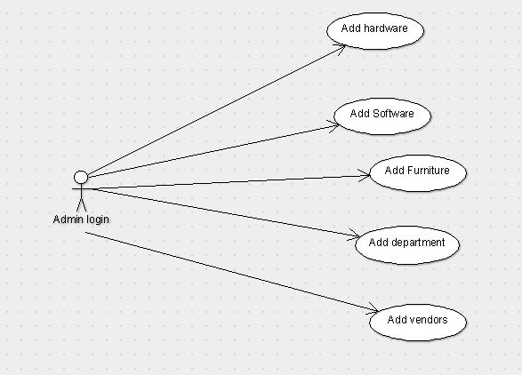

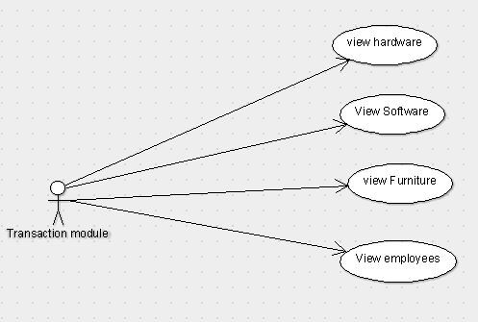

SEQUENCE DIAGRAM:

Sequence diagram and collaboration diagram are called INTERACTION DIAGRAMS. An interaction diagram shows an interaction, consisting of set of objects and their relationship including the messages that may be dispatched among them.
A sequence diagram is an introduction that empathizes the time ordering of messages. Graphically a sequence diagram is a table that shows objects arranged along the X-axis and messages ordered in increasing time along the Y-axis

State Chart Diagram

IMPLEMENTATION

OVERVIEW OF TECHNOLOGIES USED

3.1 Front End Technology

HTML/CSS, BOOTSTRAP, JAVASCRIPT

HTML is the language used to structure the web page. All web pages are written in HTML.
Features of HTML are:-
- Platform independent language

- It is not case sensitive language

- Title, Lists, Paragraph, etc

- Controls fonts, colors, positioning using CSS
(Cascading Style Sheets )

- We can build tables

Cascading Style Sheets (CSS) is a style sheet language used for describing the presentation of a document written in a markup language like HTML.[CSS is a cornerstone technology of the World Wide Web, alongside HTML and JavaScript

Features of CSS are:-

Separation of content from presentation

- Main article: Separation of presentation and content

- CSS facilitates publication of content in multiple presentation formats based on nominal parameters. Nominal parameters include explicit user preferences, different web browsers, the type of device being used to view the content (a desktop computer or mobile device), the geographic location of the user and many other variables

Site-wide consistency

- Main article: Style sheet (web development)

- When CSS is used effectively, in terms of inheritance and "cascading", a global style sheet can be used to affect and style elements site-wide. If the situation arises that the styling of the elements should be changed or adjusted, these changes can be made by editing rules in the global style sheet. Before CSS, this sort of maintenance was more difficult, expensive and time-consuming

Bandwidth

- A stylesheet, internal or external, specifies the style once for a range of HTML elements selected by class, type or relationship to others. This is much more efficient than repeating style information inline for each occurrence of the element. An external style sheet is usually stored in the browser cache, and can therefore be used on multiple pages without being reloaded, further reducing data transfer over a network

Page reformatting

- Main article: Progressive enhancement

- With a simple change of one line, a different style sheet can be used for the same page. This has advantages for accessibility, as well as providing the ability to tailor a page or site to different target devices. Furthermore, devices not able to understand the styling still display the content

Accessibility

- Without CSS, web designers must typically lay out their pages with techniques such as HTML tables that hinder accessibility for vision-impaired users (see Tableless web design #Accessibility)

Bootstrap is freely available for every user. The main features of bootstrap is, it is very simple and easy to use, hug JavaScript plugins are available, easily design mobile friendly website
Features of BOOTSTRAP are :-
- Easy to Use
- Mobile-Friendly
- Customizable Bootstrap
- Simple Integration
- Pre-styled Components
- Responsive Features
- Browser Compatibility
- Great Grid System
- Extensive list of Components
- Bundled Javascript plugins
- Good Documentation
- Base Styling for most HTML Elements

Easy to use
Anybody with just basic knowledge of HTML and CSS can start using Bootstrap

Responsive features
Bootstrap's responsive CSS adjusts to phones, tablets, and desktops

Mobile-Friendly
Mobile-first approach: In Bootstrap 3, mobile-first styles are part of the core framework

Simple Integration
Bootstrap can be simply integrated along with distinct other platforms and frameworks, on existing sites and new ones too and one more things you can also utilize particular elements of Bootstrap along with your current CSS.

Pre-styled Components
Bootstrap approaches with pre-styled components for alerts, dropdowns, nav bars, etc.

Customizable Bootstrap
The Bootstrap can be customized as per the designs of your project.

Browser compatibility
Bootstrap is compatible with all modern browsers (Chrome, Firefox, Internet Explorer, Safari, and Opera)

Great grid system
Bootstrap is built on responsive 12-column grids, layouts and components. Whether you need a fixed grid or a responsive, it's only a matter of a few changes.

Bundled JavaScript plugins
The components such as drop down menu are made interactive with the numerous JavaScript plugins bundled in the bootstrap package.

Extensive list of components
Whether you need drop down menus, pagination or alert boxes, Bootstrap has got your covered. Some of the components pre styled are; Dropdowns, Button Groups Navigation Bar, Breadcrumbs, Labels & Badges, Alerts, Progress Bar, And many others.

Base styling for most HTML elements
A website has many different elements such as headings, lists, tables, buttons, forms, etc. The HTML elements for which styles are provided are; Typography Code, Tables, Forms, Buttons, Images, Icons

Good documentation
Not only does Bootstrap offer styling for almost every element a typical website or web application requires, it also provides a great documentation with examples and demo that only make it more easier for even someone new
JavaScript is a client side technology, it is mainly used for gives client side validation
Features of JAVASCRIPT are:-
- JavaScript is a object-based scripting language.
- Giving the user more control over the browser.
- It Handling dates and time.
- It Detecting the user's browser and OS,
- It is light weighted.
- JavaScript is a scripting language and it is not java.
- JavaScript is interpreter based scripting language.
- JavaScript is case sensitive.
- JavaScript is object based language as it provides predefined objects.
- Every statement in javascript must be terminated with semicolon (;).
- Most of the javascript control statements syntax is same as syntax of control statements in C language
- An important part of JavaScript is the ability to create new functions within scripts. Declare a function in JavaScript using function keyword

3.2 BACK END TECHNOLOGY:
About Microsoft SQL Server
Microsoft SQL Server is a Structured Query Language (SQL) based, client/server relational database. Each of these terms describes a fundamental part of the architecture of SQL Server.
Database
A database is similar to a data file in that it is a storage place for data. Like a data file, a database does not present information directly to a user; the user runs an application that accesses data from the database and presents it to the user in an understandable format.

A database typically has two components: the files holding the physical database and the database management system (DBMS) software that applications use to access data. The DBMS is responsible for enforcing the database structure, including:
- Maintaining the relationships between data in the database.
- Ensuring that data is stored correctly and that the rules defining data relationships are not violated.
- Recovering all data to a point of known consistency in case of system failures.

Relational Database
There are different ways to organize data in a database but relational databases are one of the most effective. Relational database systems are an application of mathematical set theory to the problem of effectively organizing data. In a relational database, data is collected into tables (called relations in relational theory).
When organizing data into tables, you can usually find many different ways to define tables. Relational database theory defines a process, normalization, which ensures that the set of tables you define will organize your data effectively.

Client/Server:-
In a client/server system, the server is a relatively large computer in a central location that manages a resource used by many people. When individuals need to use the resource, they connect over the network from their computers, or clients, to the server.
Examples of servers are: In a client/server database architecture, the database files and DBMS software reside on a server. A communications component is provided so applications can run on separate clients and communicate to the database server over a network. The SQL Server communication component also allows communication between an application running on the server and SQL Server.
Server applications are usually capable of working with several clients at the same time. SQL Server can work with thousands of client applications simultaneously. The server has features to prevent the logical problems that occur if a user tries to read or modify data currently being used by others.
While SQL Server is designed to work as a server in a client/server network, it is also capable of working as a stand-alone database directly on the client. The scalability and ease-of-use features of SQL Server allow it to work efficiently on a client without consuming too many resources.

Structured Query Language (SQL)
To work with data in a database, you must use a set of commands and statements (language) defined by the DBMS software. There are several different languages that can be used with relational databases; the most common is SQL. Both the American National Standards Institute (ANSI) and the International Standards Organization (ISO) have defined standards for SQL. Most modern DBMS products support the Entry Level of SQL-92, the latest SQL standard (published in 1992).

SQL Server Features
Microsoft SQL Server supports a set of features that result in the following benefits:

Ease of installation, deployment, and use
SQL Server includes a set of administrative and development tools that improve your ability to install, deploy, manage, and use SQL Server across several sites.

Scalability
The same database engine can be used across platforms ranging from laptop computers running Microsoft Windows® 95/98 to large, multiprocessor servers running Microsoft Windows NT®, Enterprise Edition.

Data warehousing
SQL Server includes tools for extracting and analyzing summary data for online analytical processing (OLAP). SQL Server also includes tools for visually designing databases and analyzing data using English-based questions.

System integration with other server software
SQL Server integrates with e-mail, the Internet, and Windows.

Databases
A database in Microsoft SQL Server consists of a collection of tables that contain data, and other objects, such as views, indexes, stored procedures, and triggers, defined to support activities performed with the data. The data stored in a database is usually related to a particular subject or process, such as inventory information for a manufacturing warehouse.

SQL Server can support many databases, and each database can store either interrelated data or data unrelated to that in the other databases. For example, a server can have one database that stores personnel data and another that stores product-related data. Alternatively, one database can store current customer order data, and another; related database can store historical customer orders that are used for yearly reporting. Before you create a database, it isimportant to understand the parts of a database and how to design these parts to ensure that the database performs well after it is implemented.

Creating a new MySQL Database using phpMyAdmin in WAMP Server:-

Databases are all around us. Almost every Blog, Website, E-mail services, E-commerce sites, and Cloud storage system needs a database to store data. Drupal, WordPress, Joomla, Ghost, osCommerce, OwnCloud, to name a few, need a database to store configuration and data.
If you are working on your computer with XAMPP or WAMPserver, or using cPanel to manage your website over Internet, it is almost inevitable that you will need to create a database.
PhpMyAdmin makes creating MySQL databases a piece of cake. In two-three clicks a new database is at your disposal. In this guide, we will show you how to create a brand-new MySQL database using phpMyAdmin.

Where to find phpMyAdmin in WAMPserver?

Run WAMP server as administrator. (Right-click on the WAMP icon found in the desktop or in the start menu, then select “Run as administrator. Click "Yes" on the "User Account Control" popup.)
After WAMP server has started, you will see the WAMP icon as shown below in the notification area at the bottom-right side of the desktop


If the icon is green as shown above, all services like Apache, MySQL etc. are running. If the icon is not green, left-click on it. You will see the WAMP administrator panel as shown below. Click on “Start All Services”.
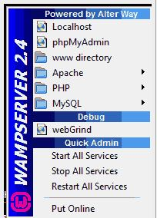
Visit “localhost” from browser. A page should be displayed as shown below. Click on “phpmyadmin” under the “Tools” section. Log in with Username and Password for MySQL. Generally, the Username is "root" with no Password required for the Super user of MySQL.
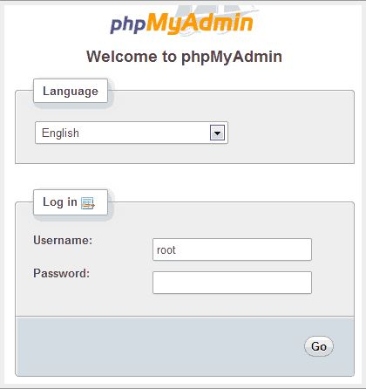

Now, it's time to create a new Database.
You will see phpMyAdmin page as shown below. Click on Databases
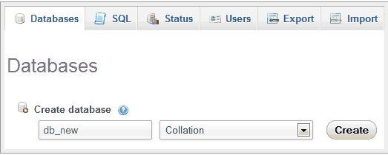

Write a database name in the “Create database” textfield, and click on Create button. A database will be created. The example below shows “db_new” as a sample database name.
Note: Don't use a dot( “.”) in the database name. You can leave the Collation drop-down as it is.

After the database has been created, phpMyAdmin will show a message telling you that a Database has been created.
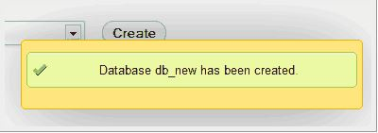
That's all for creating a new database using phpMyAdmin

PHP
PHP: Hypertext Preprocessor (or simply PHP) is a general-purpose programming language originally designed for web development. It was originally created by Rasmus Lerdorf in 1994; the PHP reference implementation is now produced by The PHP Group. PHP originally stood for Personal Home Page, but it now stands for the recursive initialism PHP: Hypertext Preprocessor.
PHP code may be executed with a command line interface (CLI), embedded into HTML code, or it can be used in combination with various web template systems, web content management systems, and web frameworks. PHP code is usually processed by a PHP interpreter implemented as a module in a web server or as a Common Gateway Interface (CGI) executable. The web server combines the results of the interpreted and executed PHP code, which may be any type of data, including images, with the generated web page. PHP can be used for many programming tasks outside of the web context, such as standalone graphical applications and robotic drone control
The standard PHP interpreter, powered by the Zend Engine, is free software released under the PHP License. PHP has been widely ported and can be deployed on most web servers on almost every operating system and platform, free of charge.
The PHP language evolved without a written formal specification or standard until 2014, with the original implementation acting as the de facto standard which other implementations aimed to follow. Since 2014, work has gone on to create a formal PHP specification.
History:-
PHP development began in 1994 when Rasmus Lerdorf wrote several Common Gateway Interface (CGI) programs in C, which he used to maintain his personal homepage. He extended them to work with web forms and to communicate with databases, and called this implementation "Personal Home Page/Forms Interpreter" or PHP/FI.
PHP/FI could be used to build simple, dynamic web applications. To accelerate bug reporting and improve the code, Lerdorf initially announced the release of PHP/FI as "Personal Home Page Tools (PHP Tools) version 1.0" on the Usenet discussion group comp.infosystems.www.authoring.cgi on June 8, 1995.
This release already had the basic functionality that PHP has today. This included Perl-like variables, form handling, and the ability to embed HTML. The syntax resembled that of Perl, but was simpler, more limited and less consistent.
Early PHP was not intended to be a new programming language, and grew organically, with Lerdorf noting in retrospect: "I don't know how to stop it, there was never any intent to write a programming language [...] I have absolutely no idea how to write a programming language, I just kept adding the next logical step on the way."A development team began to form and, after months of work and beta testing, officially released PHP/FI 2 in November 1997.
The fact that PHP was not originally designed, but instead was developed organically has led to inconsistent naming of functions and inconsistent ordering of their parameters. In some cases, the function names were chosen to match the lower-level libraries which PHP was "wrapping", while in some very early versions of PHP the length of the function names was used internally as a hash function, so names were chosen to improve the distribution of hash values.

Features of PHP:-
The main features of php is; it is open source scripting language so you can free download this and use. PHP is a server site scripting language. It is open source scripting language. It is widely used all over the world. It is faster than other scripting language. Some important features of php are given below;
It is most popular and frequently used world wide scripting language, the main reason of popularity is; It is open source and very simple.
- Simple
- Faster
- Interpreted
- Open Source
- Case Sensitive
- Simplicity
- Efficiency
- Platform Independent
- Security
- Flexibility
- Familiarity
- Error Reporting
- Loosely Typed Language
- Real-Time Access Monitoring

Simple
It is very simple and easy to use, compare to other scripting language it is very simple and easy, this is widely used all over the world.

Interpreted
It is an interpreted language, i.e. there is no need for compilation.

Faster
It is faster than other scripting language e.g. asp and jsp.

Open Source
Open source means you no need to pay for use php, you can free download and use.

Platform Independent
PHP code will be run on every platform, Linux, Unix, Mac OS X, Windows.

Case Sensitive
PHP is case sensitive scripting language at time of variable declaration. In PHP, all keywords (e.g. if, else, while, echo, etc.), classes, functions, and user-defined functions are NOT case-sensitive.

Error Reporting
PHP have some predefined error reporting constants to generate a warning or error notice.

Real-Time Access Monitoring
PHP provides access logging by creating the summary of recent accesses for the user.

Loosely Typed Language
PHP supports variable usage without declaring its data type. It will be taken at the time of the execution based on the type of data it has on its value.

Connect PHP Code with DataBase
mysqli_connect() function is used to connect php code with MySQL database. It returns resource if connection is established otherwise null.
Syntax
resource mysqli_connect (server, username, password)

PHP mysqli_close()
mysqli_close() function is used to disconnect php code with MySQL database. It returns true if connection is closed otherwise false.
Syntax
bool mysqli_close(resource $resource_link)

Connect php code with MySQL Database

Example to connect php code with MySQL Database
<?php
$servername = "localhost";
$username = "username";
$password = "password";

// Create connection
$conn = mysqli_connect($servername, $username, $password);

// Check connection
if (!$conn)
{
die("Connection failed: " . mysqli_connect_error());
}
echo "Connected successfully";

mysqli_close($conn);

?>

PHP Create Database MySQL:-
Using below syntax we can create database in MYSQL.
Syntax
CREATE Database database_name;

connect-db.php

Connect to database
<?php

$server = 'localhost';
$user = 'user_name';
$pass = 'password';
$db = 'database_name';

// Connect to Database

$connection = mysql_connect($server, $user, $pass)
or die("Could not connect to server ... \n" . mysql_error ());

// select database
mysql_select_db($db)
or die("Could not connect to database ... \n" . mysql_error ());

?>

create-database.php

Create Database in database
<?php

include 'connect-db.php';

$sql = 'CREATE Database mydb';
$result mysql_query($sql, $connection);

if($result))
{
echo "Database mydb created successfully......";
}
else
{
echo "Sorry, database creation failed ".mysqli_error($conn);
}

mysql_close($connection);

?>

Create Table Mysql PHP
Table is the collection of row and column, using below SQL query we can create own table in database.

Create Table in database
create table table_name (
id int(5) NOT NULL auto_increment,,
f_name varchar(20)
l_name varchar(20)
)
For create table in database using PHP webpage; first conncet to database then use below code.

connect-db.php

Connect to database
<?php

$server = 'localhost';
$user = 'user_name';
$pass = 'password';
$db = 'database_name';

// Connect to Database

$connection = mysql_connect($server, $user, $pass)
or die("Could not connect to server ... \n" . mysql_error ());

// select database
mysql_select_db($db)
or die("Could not connect to database ... \n" . mysql_error ());

?>

create-table.php

Create Table in database
<?php

include 'connect-db.php';

$sql = "id int(5) NOT NULL auto_increment, f_name varchar(20), l_name varchar(20)";
$result = mysql_query($conn, $sql);

if($result)
{
echo "Table user created successfully......";
}
else
{
echo "Could not create table: ". mysql_error($conn);
}

mysql_close($conn);

?>

DATABASE TABLES:

Admin Login table:

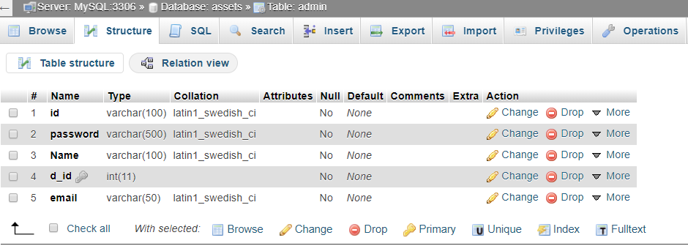

Categories table:

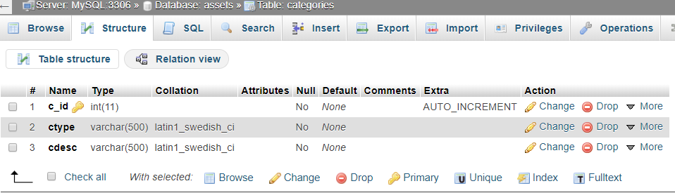

Department table:

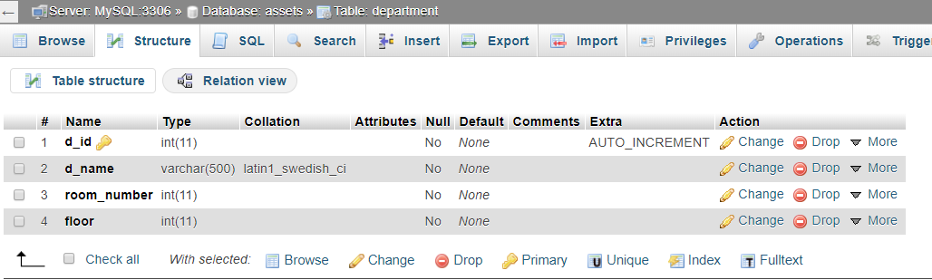

Hardware table:

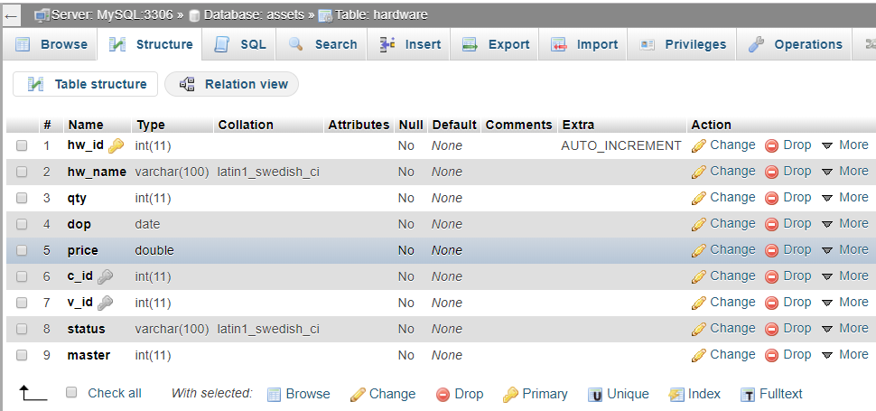

Software table:

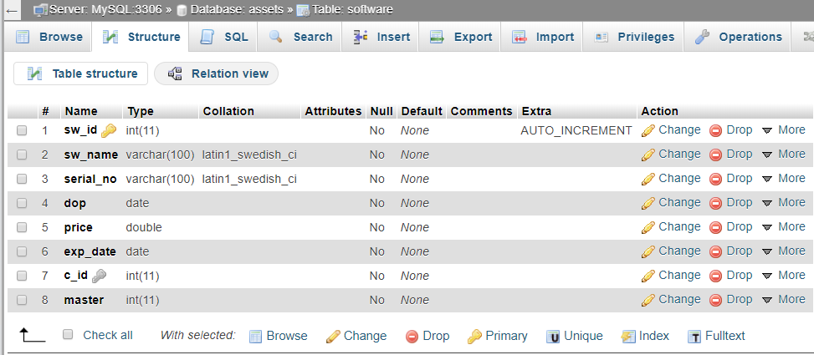

Furniture:

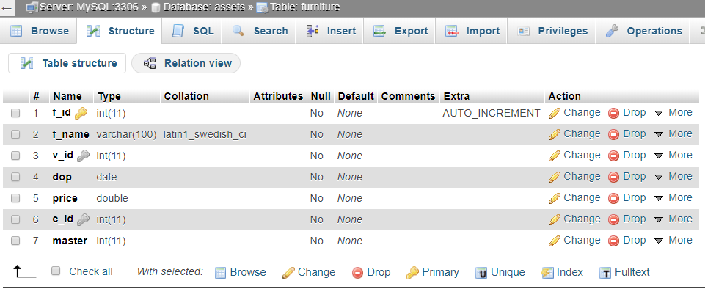

Employee table:

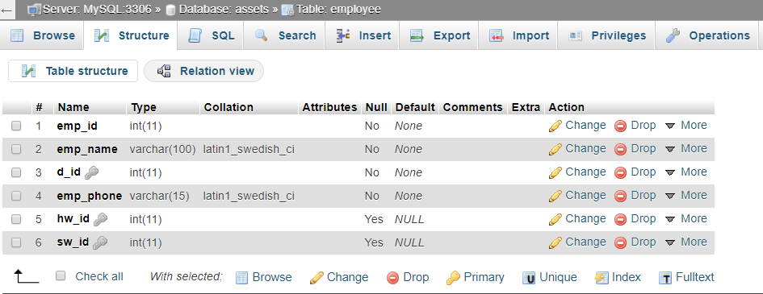

Vendors table:

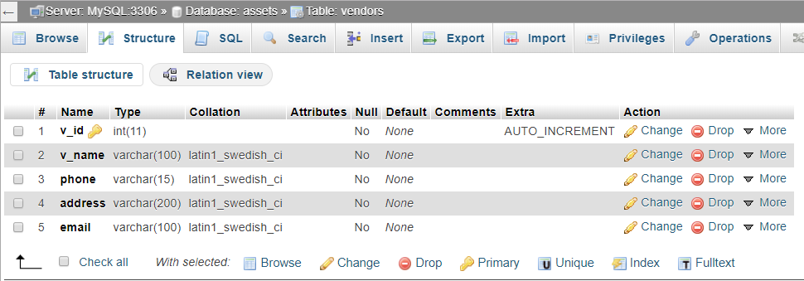

Code:
<!DOCTYPE html>
<html lang="en">
<head>
<title>Login</title>
<meta charset="UTF-8">
<meta name="viewport" content="width=device-width, initial-scale=1">
<link rel="icon" type="image/png" href="images/icons/favicon.ico"/>
<link rel="stylesheet" type="text/css" href="vendor/bootstrap/css/bootstrap.min.css">
<link rel="stylesheet" type="text/css" href="fonts/font-awesome-4.7.0/css/font-awesome.min.css">
<link rel="stylesheet" type="text/css" href="fonts/Linearicons-Free-v1.0.0/icon-font.min.css">
<link rel="stylesheet" type="text/css" href="vendor/animate/animate.css">
<link rel="stylesheet" type="text/css" href="vendor/css-hamburgers/hamburgers.min.css">
<link rel="stylesheet" type="text/css" href="vendor/animsition/css/animsition.min.css">
<link rel="stylesheet" type="text/css" href="vendor/select2/select2.min.css">
<link rel="stylesheet" type="text/css" href="vendor/daterangepicker/daterangepicker.css">
<link rel="stylesheet" type="text/css" href="css/util.css">
<link rel="stylesheet" type="text/css" href="css/main.css">
<script src="vendor/jquery/jquery-3.2.1.min.js"></script>
<script src="vendor/animsition/js/animsition.min.js"></script>
<script src="vendor/bootstrap/js/popper.js"></script>
<script src="vendor/bootstrap/js/bootstrap.min.js"></script>
<script src="vendor/select2/select2.min.js"></script>
<script src="vendor/daterangepicker/moment.min.js"></script>
<script src="vendor/daterangepicker/daterangepicker.js"></script>
<script src="vendor/countdowntime/countdowntime.js"></script>
<script src="js/main.js"></script>

</head>
<body>

<div class="limiter">
<div class="container-login100">
<div class="wrap-login100">
<div class="login100-form-title" style="background-image: url(images/bg-01.jpg);">
<span class="login100-form-title-1">
Admin Login
</span>
</div>

<form class="login100-form validate-form" action="<?php echo $_SERVER['PHP_SELF']; ?>" method="POST">
<div class="wrap-input100 validate-input m-b-26" data-validate="Username is required">
<span class="label-input100">Userid</span>
<input class="input100" type="text" name="user" placeholder="Enter username">
<span class="focus-input100"></span>
</div>

<div class="wrap-input100 validate-input m-b-18" data-validate = "Password is required">
<span class="label-input100">Password</span>
<input class="input100" type="password" name="pass" placeholder="Enter password">
<span class="focus-input100"></span>
</div>

<div class="flex-sb-m w-full p-b-30">
<div class="contact100-form-checkbox">
<input class="input-checkbox100" id="ckb1" type="checkbox" name="remember-me">
<label class="label-checkbox100" for="ckb1">
Remember me
</label>
</div>

<div>
<a href="#" class="txt1">
Forgot Password?
</a>
</div>
</div>

<div class="container-login100-form-btn">
<button>
<input type="submit" value="Login" name="submit"/>
</button>
</div>
</form>
</div>
</div>
</div>

<?php

if($_SERVER['REQUEST_METHOD'] == 'POST')
{
//session_start();
//try
//{
$pdo = new PDO('mysql:host=localhost;dbname=assets', 'root','');
$pdo->setAttribute(PDO::ATTR_ERRMODE,PDO::ERRMODE_EXCEPTION);
//}
/*catch(PDOException $e)
{
echo $e;
exit('Database error.');
}*/
if(isset($_POST['submit'])){

if(!empty($_POST['user']) && !empty($_POST['pass'])) {
$user=$_POST['user'];
$pass=$_POST['pass'];

$query = $pdo->prepare("SELECT * FROM admin WHERE id = '$user' AND password = '$pass'");
$query ->execute();
$result = $query->fetchall();

foreach ($result as $array) {
if ($array['id'] == $user && $array['password'] == $pass){
$_SESSION['id'] = $user;
header("Location: adminhome.html");
}
else{
echo '<script language="javascript">';
echo 'alert("Incorrect username or password")';
echo '</script>';
echo '<meta http-equiv="refresh" content="0;url=demo.php" />';
}
}
}
}
}
?>

</body>
</html>

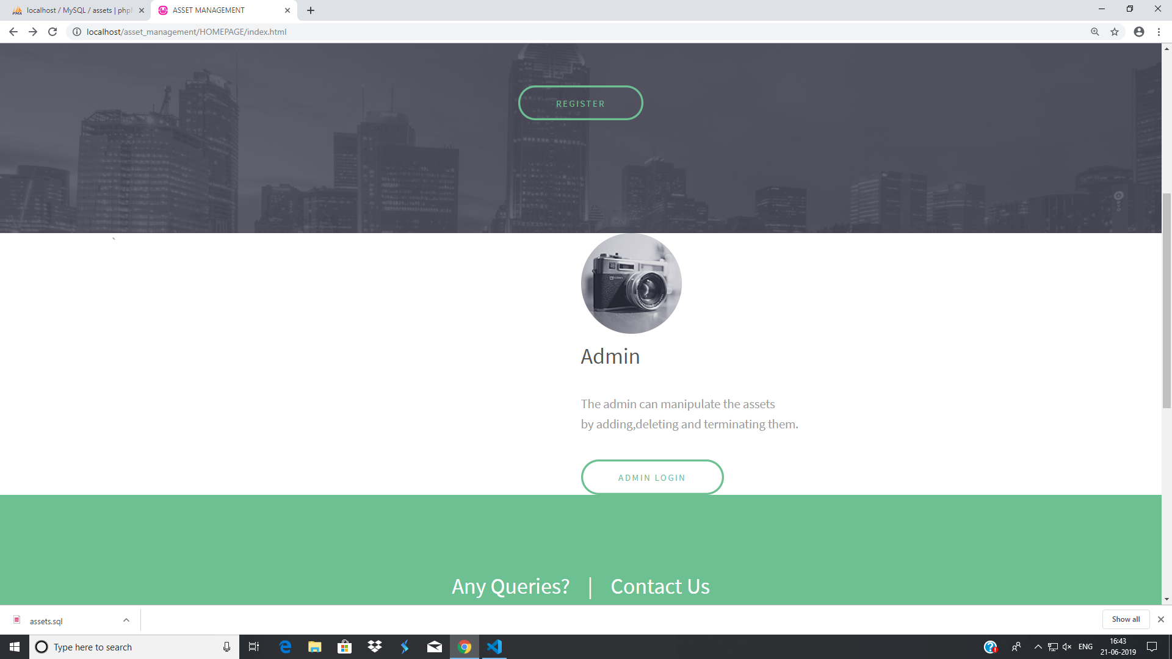

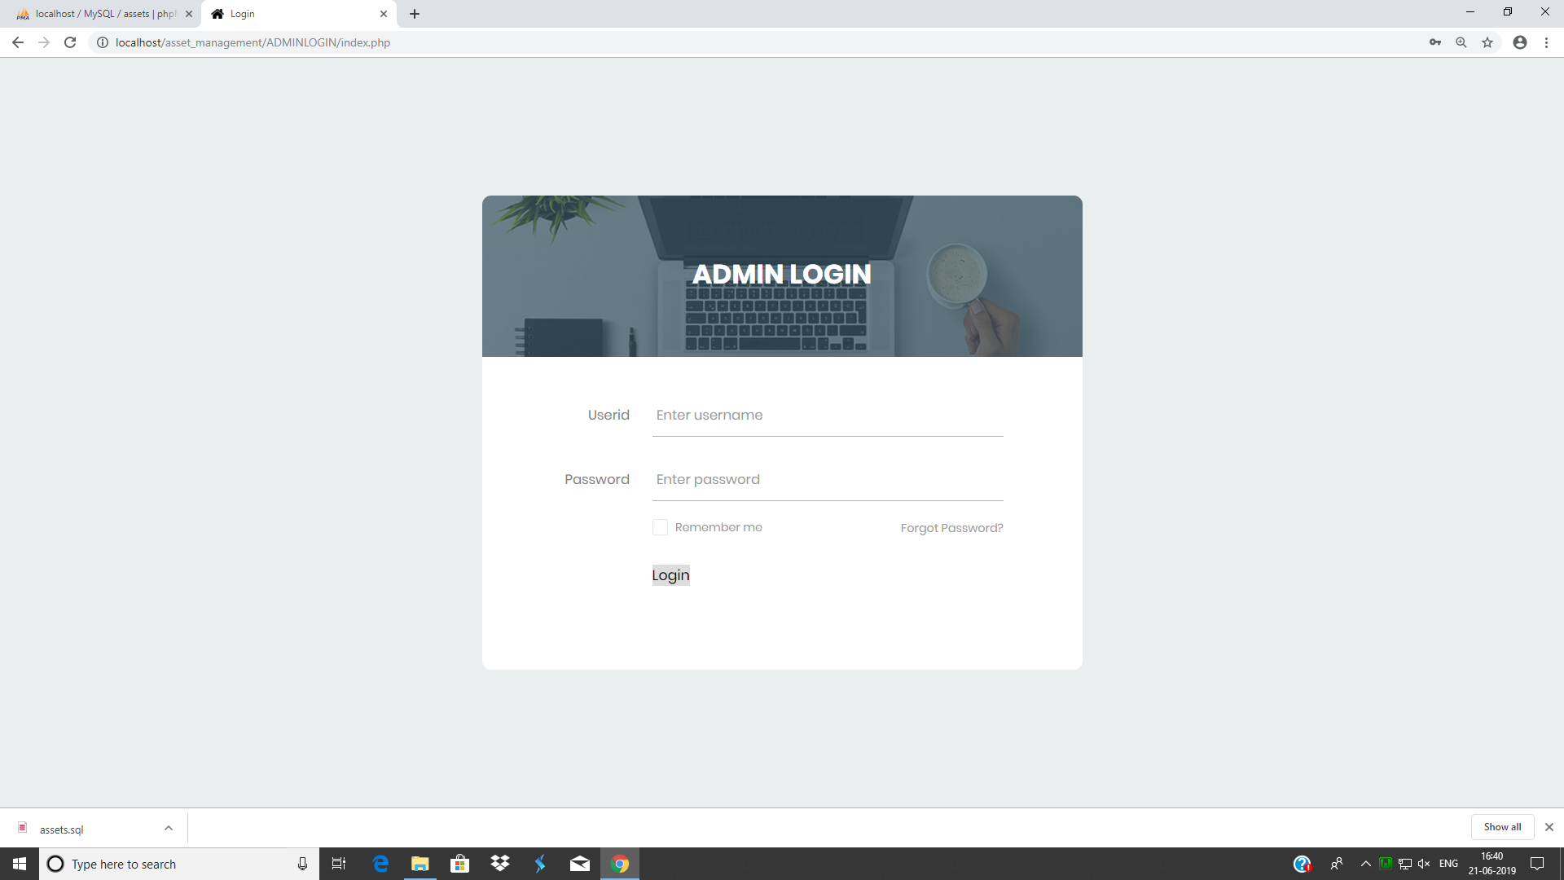

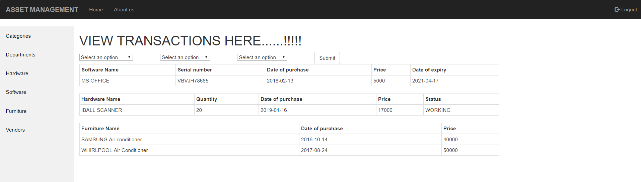

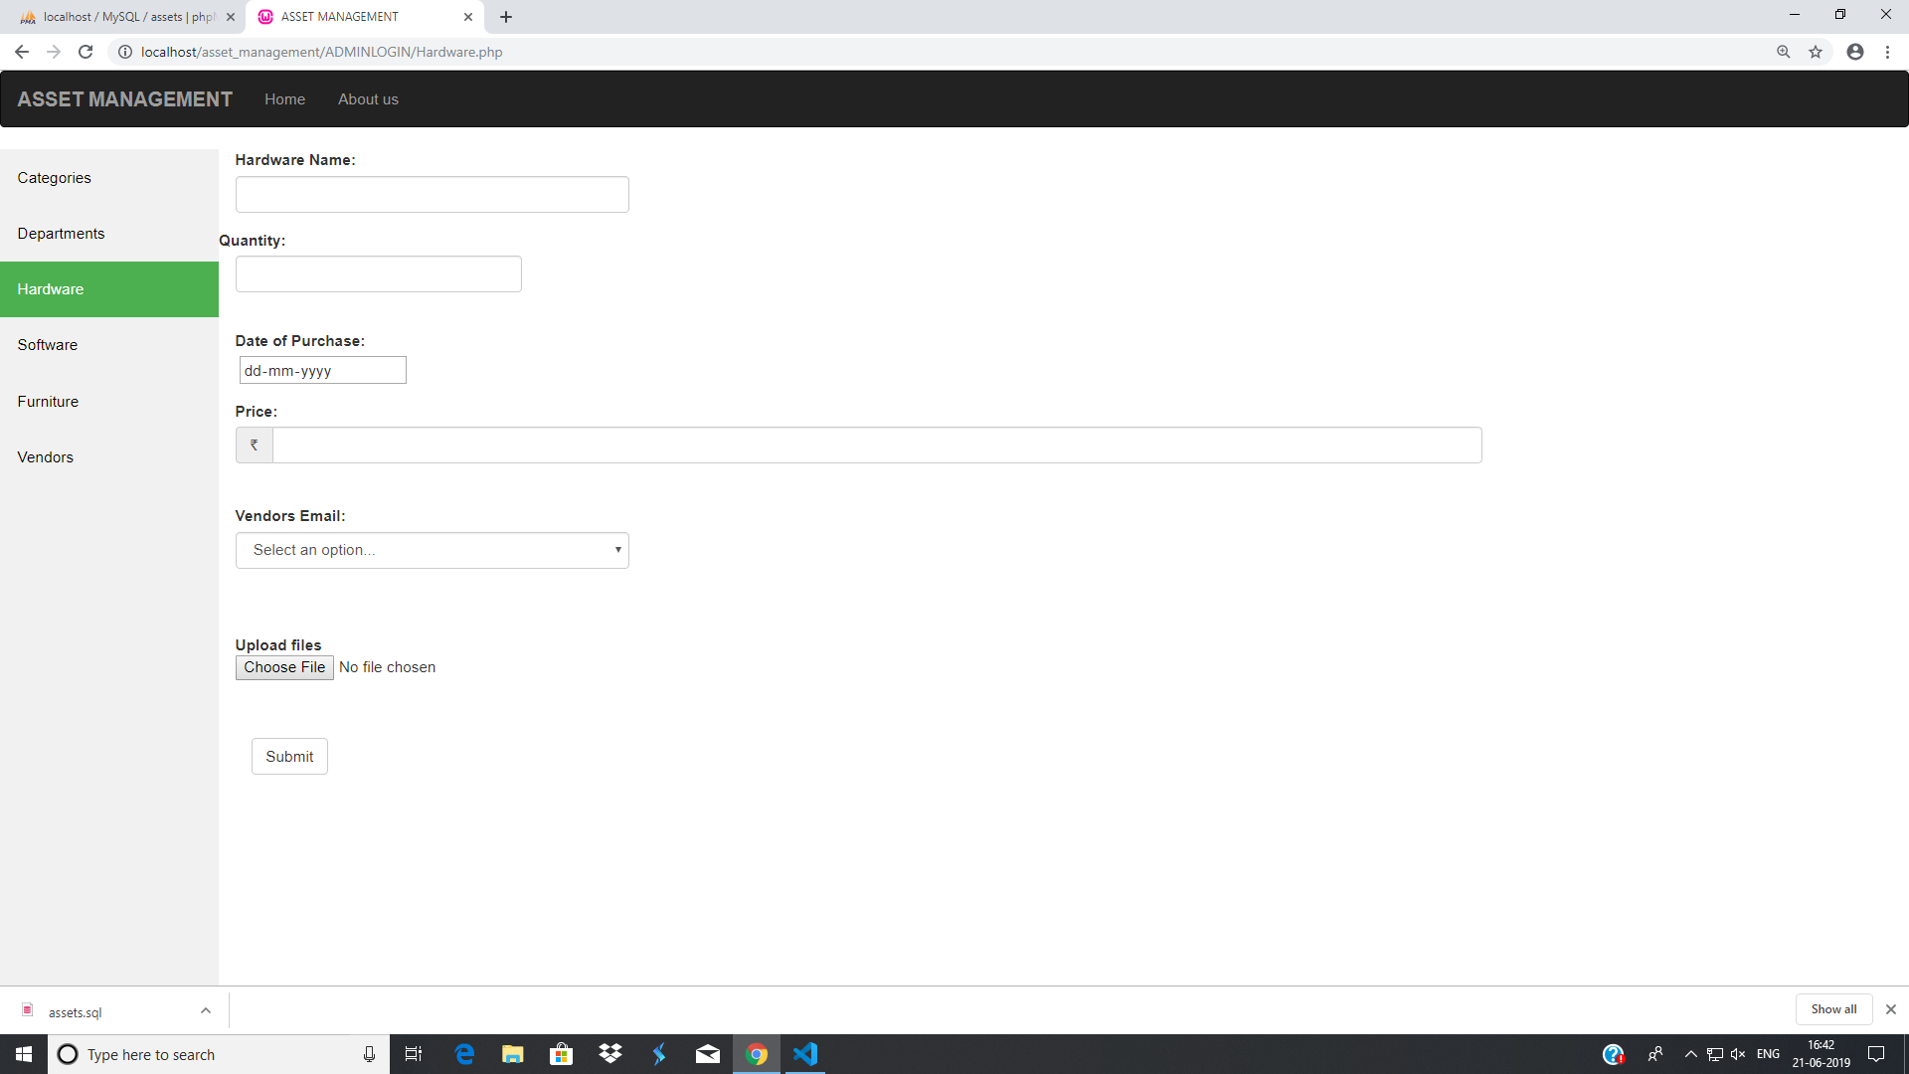

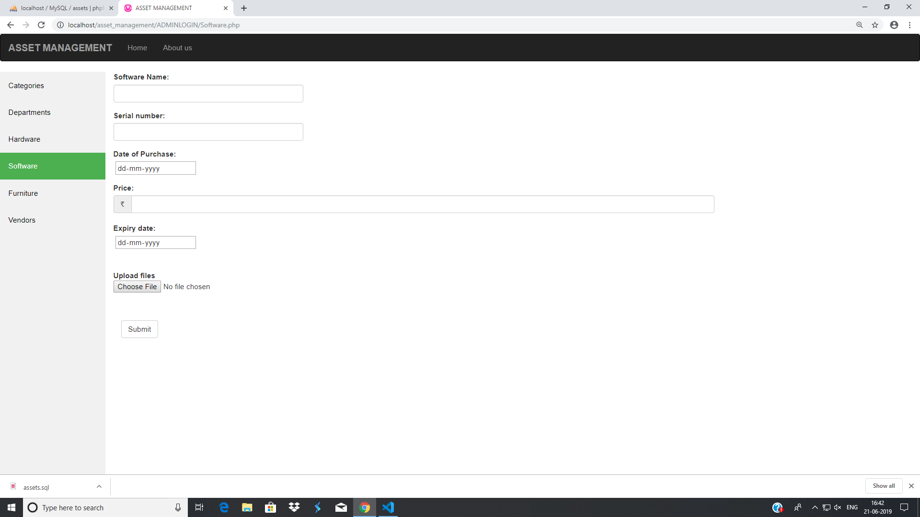

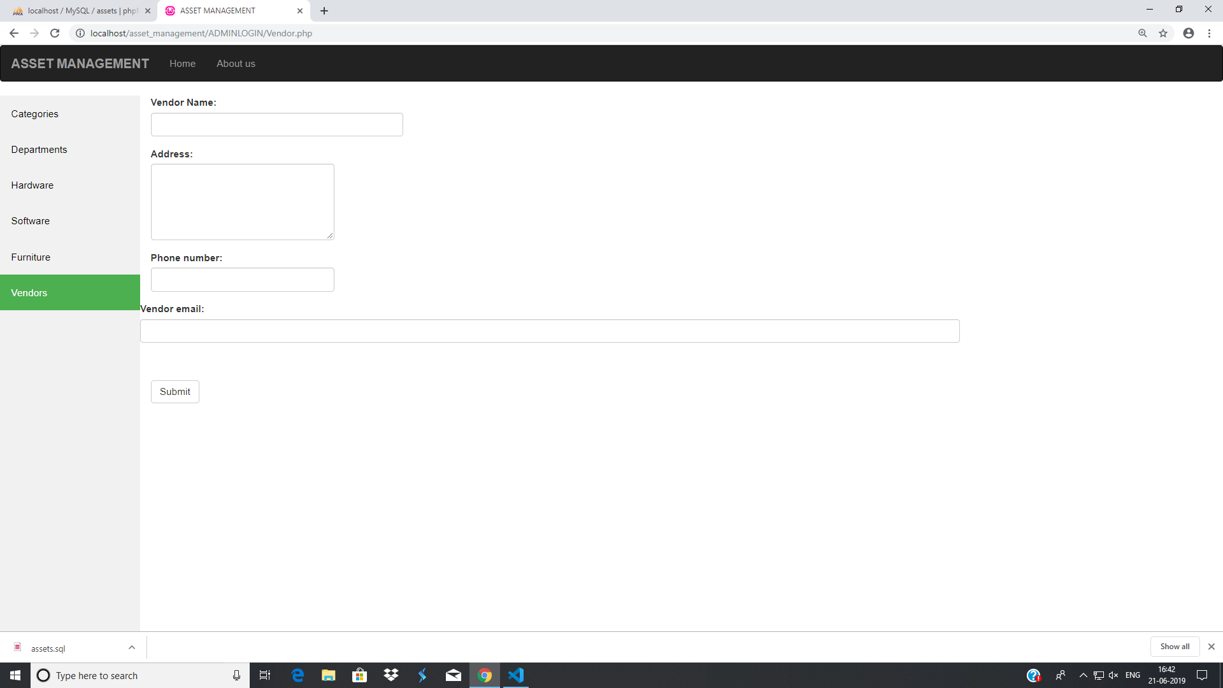

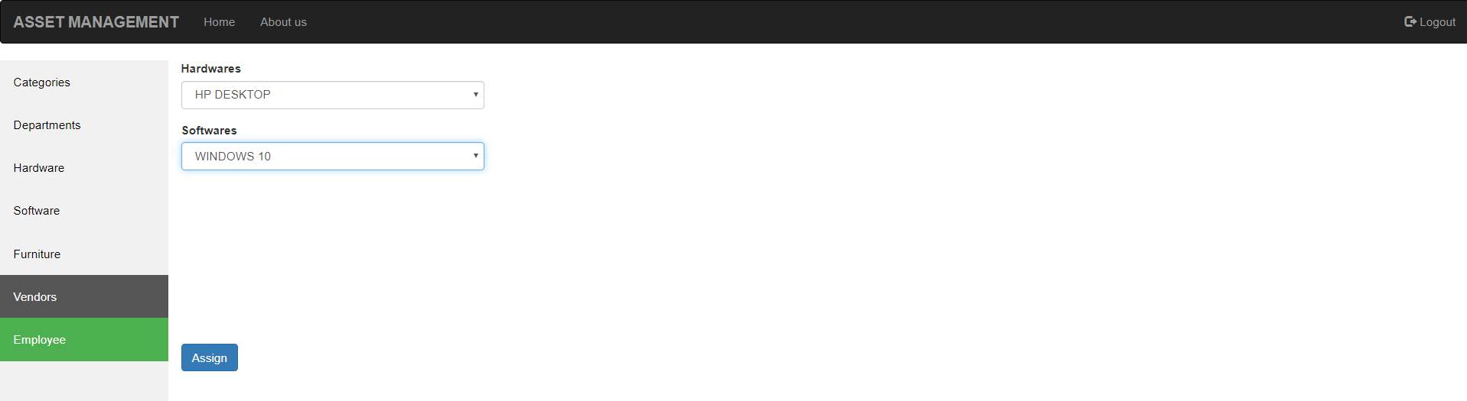

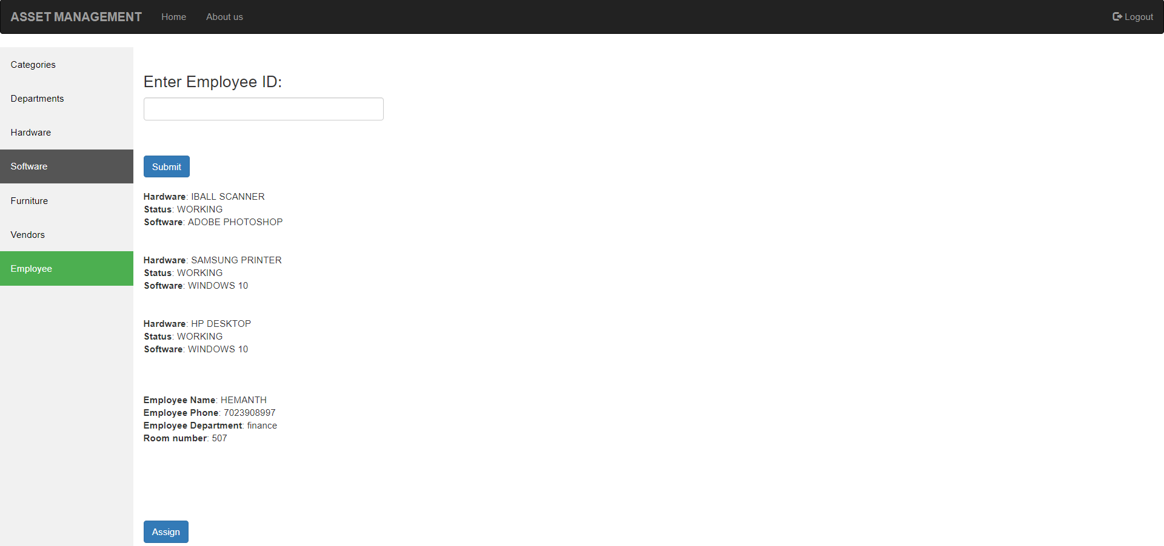

CONCLUSION:

The package was designed in such a way that future modifications can be done easily. The following conclusions can be deduced from the development of the project.

  - Automation of the entire system improves the efficiency
  - It provides a friendly graphical user interface which proves to be better when compared to the existing system.
  - It gives appropriate access to the authorized users depending on their permissions.
  - It effectively overcomes the delay in communications.
  - Updating of information becomes so easier.
  - The System has adequate scope for modification in future if it is necessary.

